**DAILY ONLINE ACTIVITIES SUMMARY**

|  |  |  |  |  |  |  |  |  |
| --- | --- | --- | --- | --- | --- | --- | --- | --- |
| **Date:** | **22-05-2020** | | | | | **Name:** | **Pavana P** | |
| **Sem & Sec** | **6A** | | | | | **USN:** | **4AL17CS057** | |
| **Online Test Summary** | | | | | | | | |
| **Subject** | | **Operation Research.** | | | | | | |
| **Max. Marks** | | **30** | | **Score** | | | **30** | |
| **Certification Course Summary** | | | | | | | | |
| **Course** | **DATA SCIENCE WITH OPEN DATA** | | | | | | | |
| **Certificate Provider** | | | Cognitive classes | | **Duration** | | | 4 hours |
| **Coding Challenges** | | | | | | | | |
| **Problem Statement:**  1.Write a C Program to implement various operations of Singly Linked List Stack.  2.Write a Java Program to separate the Individual Characters from a String  3.Write a Java Program to find the largest and smallest word in a string. | | | | | | | | |
| **Status: Completed** | | | | | | | | |
| **Uploaded the report in Github** | | | | | **YES** | | | |
| **If yes Repository name** | | | | | **DAILY STATUS** | | | |
| **Uploaded the report in slack** | | | | | **YES** | | | |

**Online Test :**

Subject:-Operating Research.

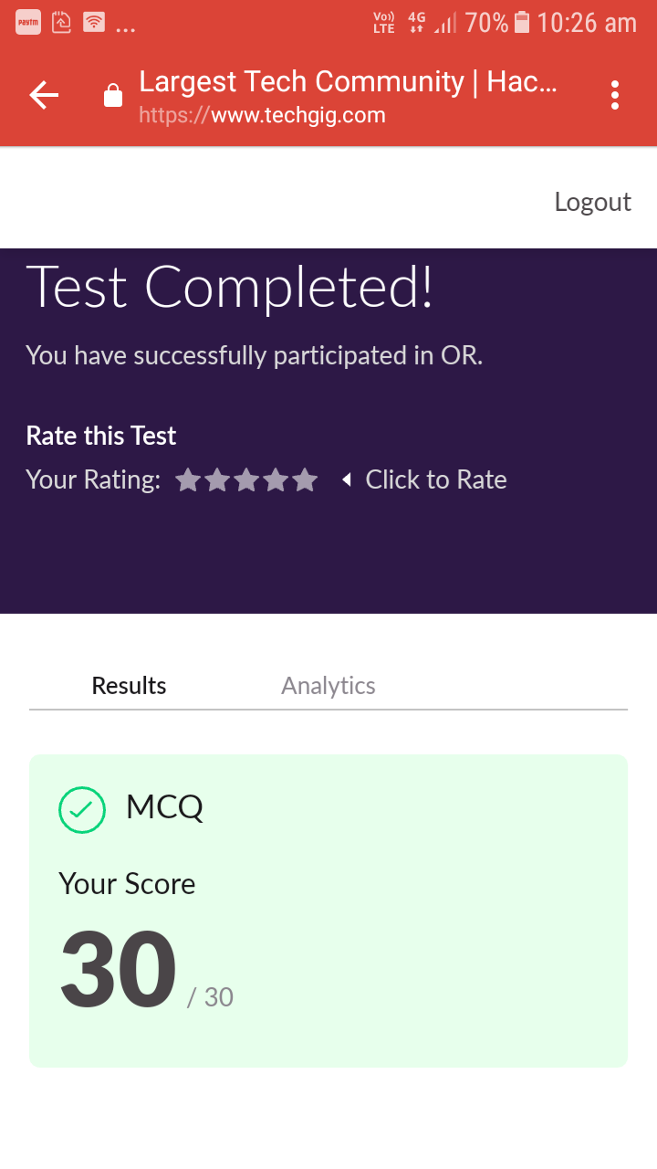

**Certification Course Details:**

**Data Science with Open Data :**

Today I have completed these topics:

1.What is Open Data and benefits of Open Data.

2.Up and Running with R, R script Instructions.

3.The Pyramid Principle.

4.Data Analysis.

.

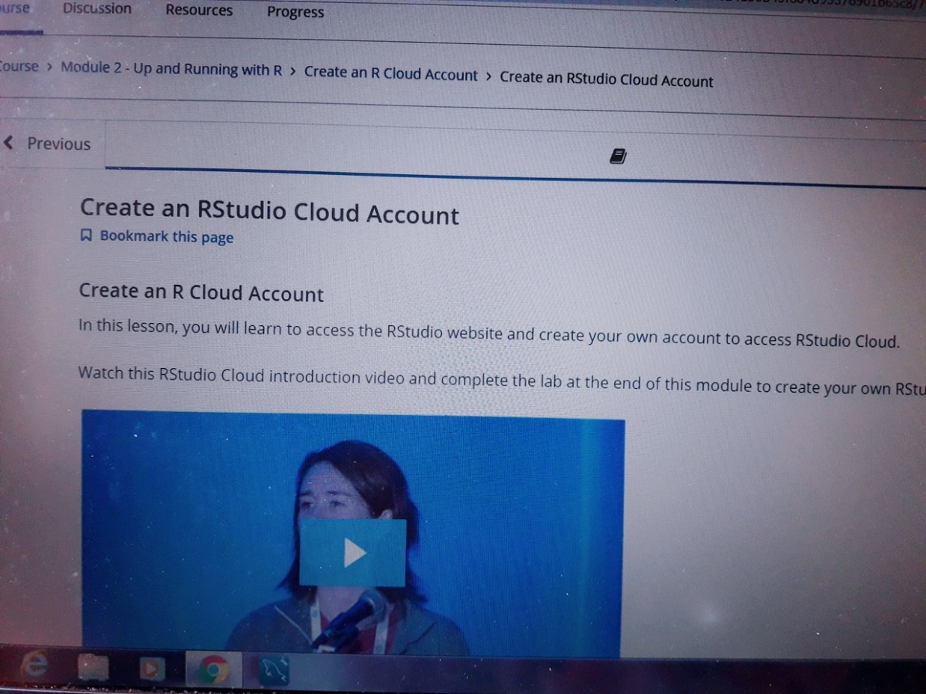

**Coding Challenges Details:**

**https://github.com/pavana-p-kulal/DAILY-STATUS/tree/master/22-5-20/Online%20Coding**